Discussion Guide for
THE SEVEN TALES OF TRINKET
By Shelley Moore Thomas
This teacher resource is aligned with the Common Core Standards for Language Arts for grades 3-8.
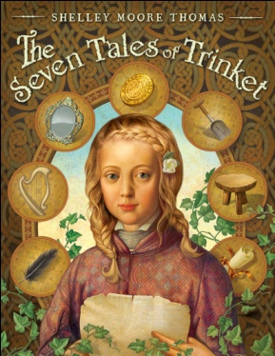
Seven Questions for THE SEVEN TALES OF TRINKET
1. Feather the Gypsy Princess tells Trinket the difference between “foreseeing the future” and “creating your own future.” How do you feel about Feather’s view? Do you agree with her or not? Why? (CCS Craft and Structure, 6)
2. Along the way, Trinket and Thomas meet many unusual creatures (selkies, banshees, pookas, ghosts, faeries). Which of these do you think is the strangest? Why? (CCS Key Ideas and Details, 3)
3. The characters of Thomas and Trinket both possess many strengths and weaknesses. What is Trinket’s biggest strength? Her biggest weakness? What are the strengths and weaknesses of Thomas? How do the characters complement each other? (CCS Key Ideas and Details, 3)
4. How is the setting and the mood different in the stories “The Faerie Queen and the Gold Coin,” and “A Pig-Boy, a Ghost, and a Pooka?” How does the mood influence the plot of these stories? (CCS Key Ideas and Details, 3)
5. In “The Storyteller and the Truth,” there is a change in the narration style. How does this impact the story? Why do you think the author chose to make this change? (CCS Craft and Structure, 6)
6. There are several themes that thread through THE SEVEN TALES OF TRINKET. Choose one main idea of the story and give examples to support your view. (CCS Key Ideas and Details, 2)
7. “The Storyteller and the Truth” ends with two endings. Which do you think Trinket chose? Why? (CCS Key Ideas and Details, 1)

